SOIL COMPACTION
Compaction: definition and importance
Compaction is the term used to describe the process where, by mechanical means, increase in soil density is achieved by decreasing the air voids content with the water content remaining approximately the same. In practice, compaction is carried out on materials which are being used as fill material, as in the construction of embankments but may also be carried out on natural soils, in situ, as in the case of the sub-base of roads and ground improvement projects.

The primary objective of compaction is to improve the engineering properties of the soil in any of the following ways:
- by increasing the shear strength and thereby improving the stability of embankments and the bearing capacity of foundations and pavements;
- by decreasing compressibility and thereby reducing settlements;
- by decreasing the void ratio and thereby reducing the soil permeability;
- by reducing the potential for swelling and shrinkage.

Compaction is carried out by rolling or tamping and causes compression of the soil by expelling air from the voids. The energy expended during the compaction process is called the compactive effort. It is not possible to remove water from the voids by compaction but the addition of water to a slightly moist soil facilitates compaction by reducing surface tension.

Compaction Tests
Laboratory compaction test essentially involves compacting a specimen of moist soil into a cylindrical mould of specified volume under a specified compactive effort. The mould is trimmed and weighed. Once the compacted specimen has been prepared, its bulk density ($ρ_{wb}$) and water content ($θ_{m}$) are readily determined and the corresponding dry bulk density ($ρ_{d}$) appropriate to that water content can be calculated as:

$$ρ_{d}= \frac{ρ_{wb}}{1+θ_{m}}$$

This procedure is carried out at least five times over a range of water contents and the compaction characteristics of the soil presented in the form of a graph of dry bulk density against water content. Typical curves show a trend of increasing dry bulk density with increasing water content to a peak value and then decreasing again at high water contents. The peak defines the optimum water content at which the soil obtains its maximum dry bulk density. The reason for this trend of the compaction curve is not fully understood but it is generally thought to be more than simply a matter of the addition of water contributing to lubrication at particle contact points and an improved workability. A possible explanation is that as the water content increases, sufficient water becomes available to penetrate and help break up the lumps while allowing adsorbed water layers to develop more fully around the clay mineral particles in the fines. This reduces inter-particle bonding, permitting a greater orientation of the clay particles and the development of a more dispersed microstructure. Beyond the optimum value, however, increases in water content are progressively less effective in reducing the small air voids content. Much of the compactive effort is absorbed by the pore water as excess pore water pressure, the soil particles are displaced rather than compacted and increases in void space and therefore lower densities result.

A number of compaction tests are in use (Table 1), the most popular being the Proctor test used by the American Society for Testing of Materials (ASTM) and the American Association for State Highways and Transportation Organization (AASHTO).

Table 1. Laboratory compaction tests

Test | Standard Reference | Rammer |  | Volume of Mould | Layers | Blows per layer
Test | Standard Reference | Mass | Height of Fall | Volume of Mould | Layers | Blows per layer
2.5 kg rammer method | BS 1377: 1975 Test 12 | 2.50 kg | 300 mm | 1000 cm³ | 3 | 27
4.5 kg rammer method | BS 1377: 1975 Test 13 | 4.50 kg | 450 mm | 1000 cm³ | 5 | 27
Standard Proctor | ASTM D-698-78 | 2.49 kg | 305 mm | 944 cm³ | 3 | 25
Standard AASHTO | AASHTO T-99
Modified Proctor | ASTM D-1557-78 | 4.54 kg | 457 mm | 944 cm³ | 3 | 25
Modified AASHTO | AASHTO T-180

The effect of applying different compactive efforts is illustrated by the two compaction curves obtained for the same soil under different test conditions (Figure 1).

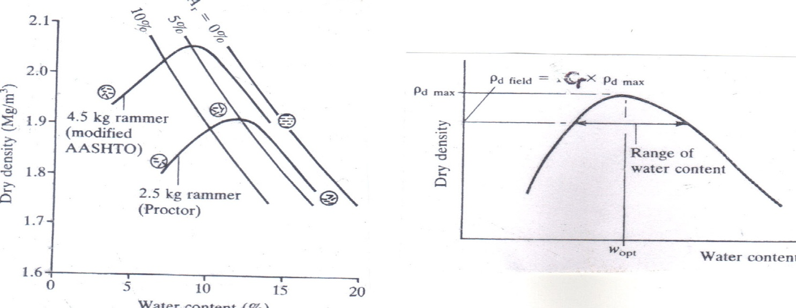

Figure 1. Compaction characteristics of soils Figure 2. Relative compaction

A higher compactive effort is seen to give higher maximum dry density but lower optimum water content. For any water content, the equivalent dry bulk density of a soil will theoretically achieve its highest value at full saturation, that is, when the air voids ratio is reduced to zero. In practice, however, it is not possible to achieve conditions of full saturation simply by compaction; a small quantity of air will always remain in the voids. Thus if the theoretical zero air voids line or saturation line is superimposed on the plot of test results, the laboratory compaction curve must lie entirely to the left of the zero air voids line. The theoretical relationship between dry bulk density ($ρ_{d}$), wet bulk density ($ρ_{wb}$), specific gravity of soil particles ($G_{s }$), water content ($θ_{m}$) and air voids content ($θ_{a}$) has been established as:

$$ρ_{d}= \frac{\left(1-θ_{a}\right)G_{s }}{1+{G_{s}θ}_{m}}ρ_{wb}$$

This equation can be used to plot not only the zero air voids line but also the theoretical lines of, for example 5 % and 10 % air voids ratio. It is seen that shortly after passing through the peak, the compaction curve becomes approximately parallel to the lines of constant air voids, indicating an essentially constant minimum air voids content. Also, the minimum air voids content is largely independent of the compactive effort applied.

Compaction Equipment and Field Compaction
The extent to which field compaction is effective depends on many factors, including the type of soil, its water content, type of compaction equipment, speed of coverage and number of passes. The equipment used to produce compaction in the field includes vibrating plates, power rammers and many different types of rollers, the commonest types of which include smooth wheeled rollers, sheepsfoot rollers, rubber-tyred rollers and vibratory rollers.

Once the compaction characteristics of the fill material have been defined by standard laboratory tests but before earthworks have begun, it is necessary to prepare specifications to ensure that adequate and effective field compaction is achieved. The compaction specifications either define the end result to be achieved or the method of compaction. When specification is in terms of the end result to be achieved, common practice is to prescribe a required relative compaction (Figure 2), defined as the ratio of field dry bulk density to the maximum dry density obtained in a standard laboratory test:

$${Relative Compaction (C}_{r})= \frac{ρ_{dfield}}{ρ_{dmax}}$$

Relative compaction is usually expressed as a percentage, with the typical requirement being for values in the range 90 – 100 %.

Problem
Standard Proctor compaction tests carried out on a sample of sandy clay yielded the following results:

Wet bulk density (kg/m³) | 2058 | 2125 | 2152 | 2159 | 2140
Water content (% mass) | 12.9 | 14.3 | 15.7 | 16.9 | 17.9

- Plot the curve of dry bulk density against water content and hence find the maximum dry bulk density and the optimum water content.
- Calculate the water content necessary for complete saturation at this maximum dry bulk density if the specific gravity of the soil particles is 2.70.
- Plot the zero air voids and 5 % air voids line superimposed on the same diagram.

